NTOMBIZA MPAHLENI

BRIGHTLIGHT TUTORIAS

EXERCISE 1

1. SELECT Statement Write a SQL query to retrieve all columns from the employee’s table.

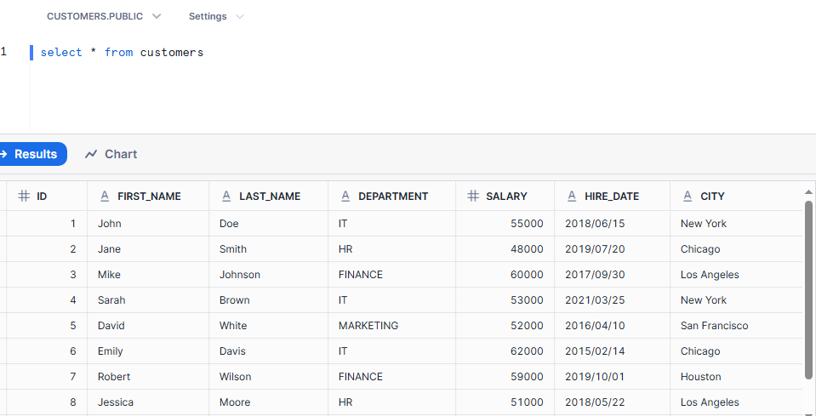

1. SELECT DISTINCT Statement Write a SQL query to find all the unique departments in the employee’s table.

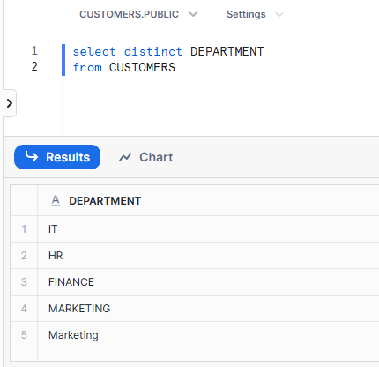

1. ORDER BY Statement Write a SQL query to retrieve all employees' first and last names, ordered by salary in descending order.

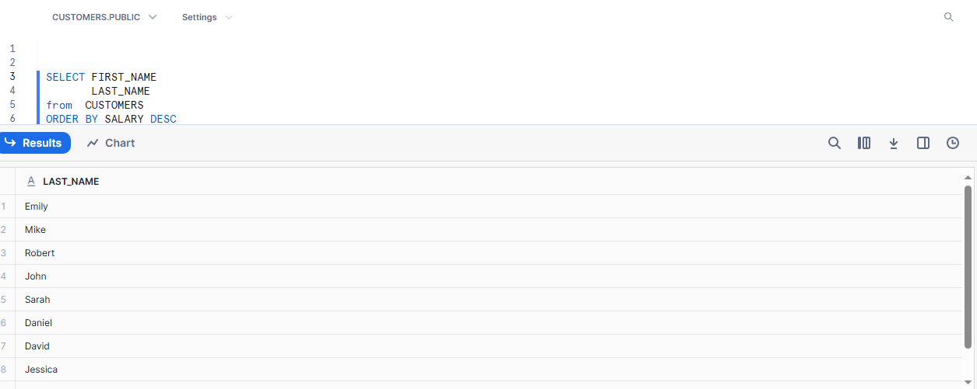

1. LIMIT Statement Write a SQL query to retrieve the top 5 highest-paid employees.

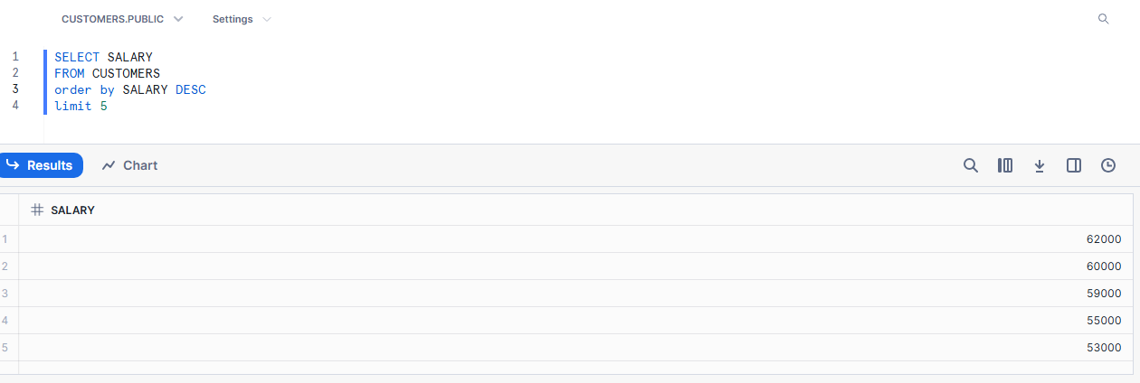

1. WHERE Statement Write a SQL query to find employees who work in the IT department.

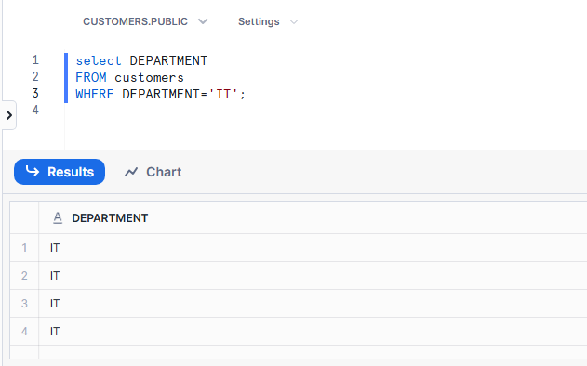

1. AND Statement Write a SQL query to find employees who work in the Finance department AND have a salary greater than 58,000.

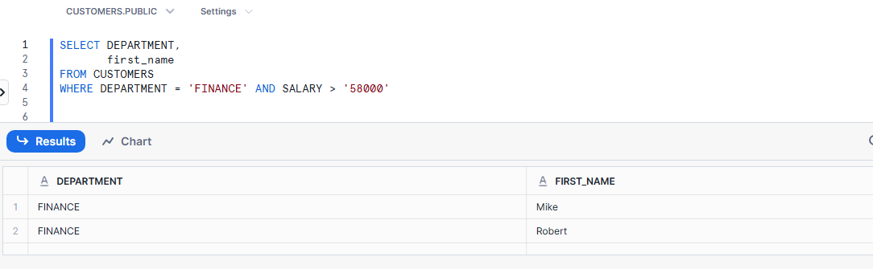

1. OR Statement Write a SQL query to find employees who work in the HR department OR the Marketing department. 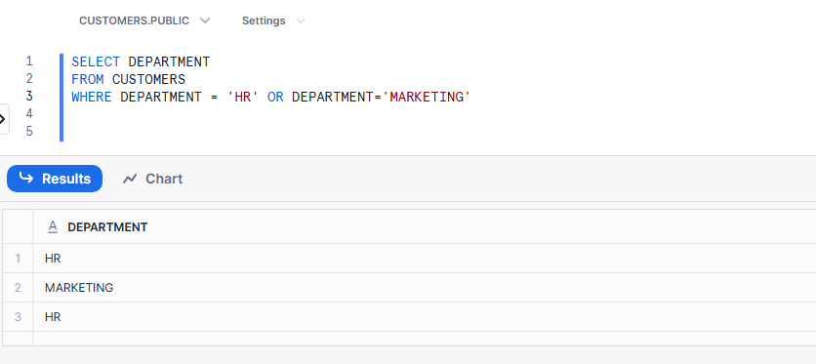
2. NOT Statement Write a SQL query to find employees who do not work in the IT department.

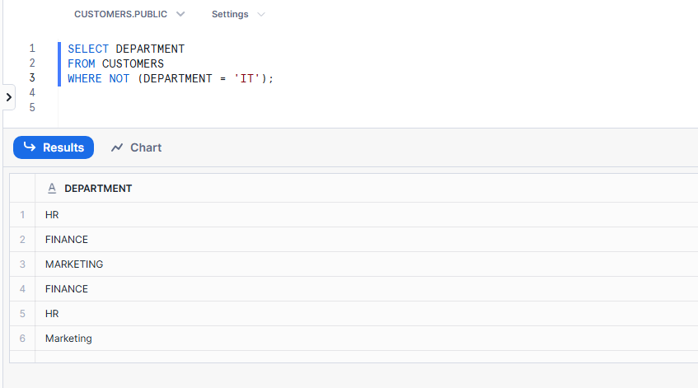

9.IN Statement Write a SQL query to find employees who are in the HR, IT, or Finance departments.

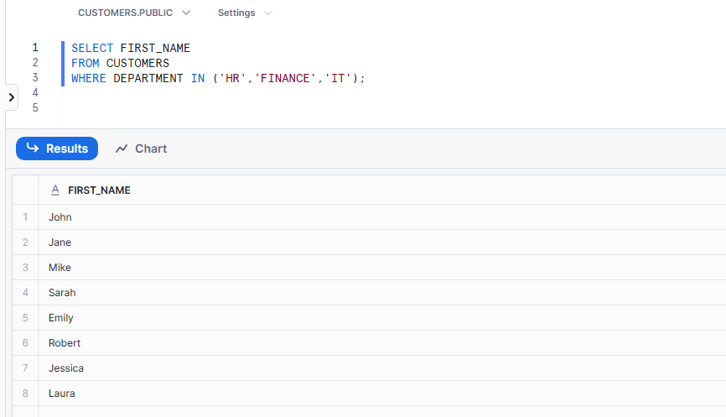

10. Combining Conditions Write a SQL query to find employees who are in the IT department, have a salary greater than 50,000, and are located in New York.

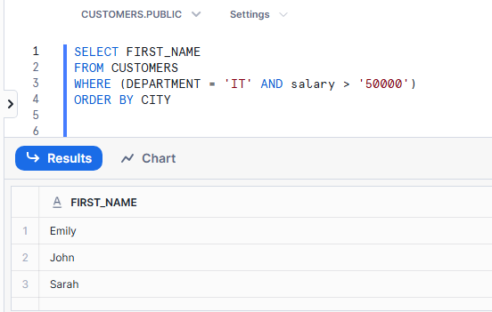

11. Combining WHERE, AND, and ORDER BY Write a SQL query to retrieve the first and last names of employees who work in the Finance or Marketing department, earn more than 52,000, and order the results by salary in descending order.

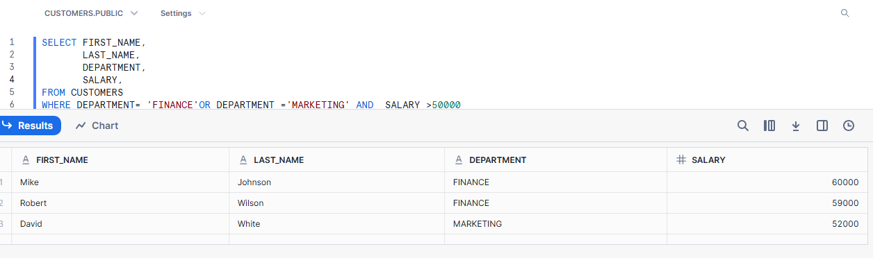

12. Combining SELECT DISTINCT, WHERE, and IN Write a SQL query to find all the unique cities where employees work, excluding those in the IT and HR departments.

13. Combining WHERE, NOT, AND, and ORDER BY Write a SQL query to retrieve employees who are NOT in the Finance department, have a salary greater than 50,000, and order the results by hire date in ascending order.

14. Combining WHERE, OR, IN, and LIMIT Write a SQL query to find the first 3 employees who work in either Chicago or Los Angeles and belong to the IT or Marketing department.